# User-friendly AI hardware for EV charging using RFID.

# Dr. Sumitra V1 ,OmminaMasthan Murali2, Chinni Sumanchaitanya3Bala srinivas segu4

# Chinnaguruvagaari Yoga vardhan5, Dr. Sumitra V (M.E., Ph.D) – AP/ECE1,

# (email:[vsa.ece@rmkec.ac.in](mailto:skn.ece@rmkec.ac.in))

# 2Students IV Year, ECE R.M.K Engineering college, Kavaraipettai, Tamilnadu–601206.

* ***Abstract:*** *Electric mobility is a promising global strategy for decarburizing the transportation sector. This project aims to have at least 30% of new vehicle sales be electric by 2030. The Indian government has implemented a number of enabling policies to encourage the development of a charging infrastructure network. This project primary audience consists of public and private sector stakeholders in charge of charging infrastructure implementation, such as electricity distribution companies. and charge point solutions providers and operators. This paper offers the improvement and validation of the charging station to be access easily using CURRENCY based architecture. The current EV station method allows users to access the station solely through the application. And the main issue with the current system is that we cannot disconnect the charger for emergency purposes while it is charging. We lose the specified amount of money if we disconnect the charger. So in this paper we proposed CURRENCY based return policy EV station to rectify the problems.*

## OBJECTIVE

To design and develop an automated system tothe aim of our project is a CURRENCY based EV charging station with a data analysis feature.

## INTRODUCTION

## Electric mobility is a promising global decarburization solution for the transportation industry. The Indian government has implemented a number of enabling laws to encourage the construction of a charging infrastructure network.

## This project aims to develop and validate the charging station so that it can be conveniently accessed using a money based user setup architecture. Existing EV station technique allows users to access the station solely through the application. And the main issue with the current system is that we cannot unplug the charger for emergency purposes while it is charging. We lose the specified amount of money if we disconnect the charger.

## EXISTINGSYSTEM:

## In this system, there is the only option to access the device is using card. We cannot unplug the charger for emergency purposes while it is charging. We lose the specified quantity of money if we disconnect the charger.

## Drawbacks of existing system

## There is no option to use physical currency (coin).

## Loss of Money.

## No return policy for the unused charging time.

## PROPOSEDSYSTEM:

## We can handle both cards and physical currency in this system. Also given the return policy for the unused charging time in the previous usage time.

## Advantages of proposed system

## Option to use card and card-less.

## No Money loss.

## Return policy for the unused charging time.

## BLOCKDIAGRAM

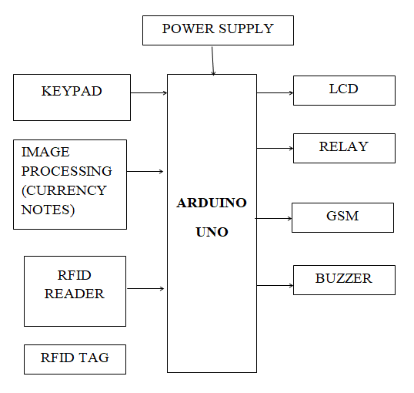

**Modules:**

* **CURRENCY ACCEPTER MODULE**
* **IDENTIFICATION**

Currency Accepter Module Working:

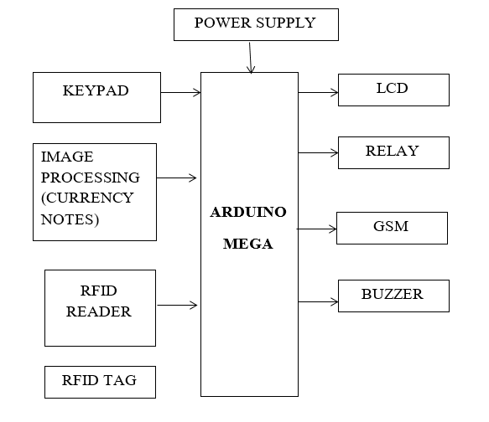

Identification:

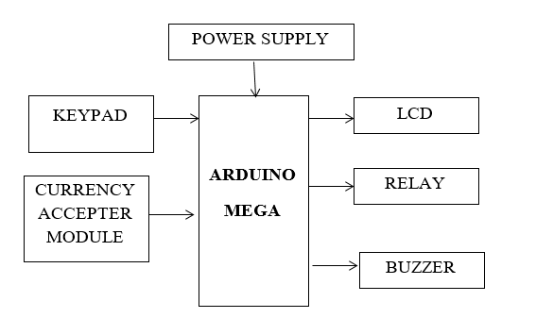

1. **HARDWARE REQUIREMENTS**
2. ARDUINO UNO
3. POWER SUPPLY
4. LCD
5. KEYPAD
6. RELAY
7. RFID READER
8. RFID TAG
9. GSM
10. BUZZER

## POWER SUPPLY

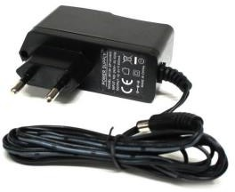**Features:**

* + It produces an output current of 1A.
  + The supply voltage we get from using power supply is 220 – 230 v AC.
  + The output voltage in dc is 12VDC
  + Reduced costs
  + Value has been increased in both front-office and back-office tasks.
  + Data that is current, precise, and consistent
  + It generates adapter met a data as WSDL files with J2CA extension.

## MICROCONTROLLER:(ARUDINO MEGA)

**SPECIFICATIONS:**

* Microcontroller: ATmega2560P
* Operating Voltage: 5V
* Input Voltage (recommended): 7-12V
* Input Voltage (limit): 6-20V
* 14 digital I/O pins (of which 6 provide PWM output) PWM Digital I/O Pins: 6
* Analog Input Pins: 6
* DC power of 20 milli amperes per I/O port

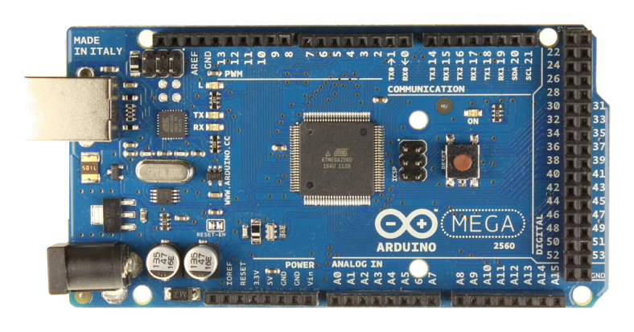

## 9. KEYPAD MODULE

## 

**Features:**

* + The maximum rating is 24 VDC, 30 mA.
  + The interface consists of 8-pin access to 4×4 matrix.
  + The temperature ranges are: 0 to 50 °C to 122 °F

## Applications:

* + It is used in security systems, data entry systems, industrial control systems
  + It is used in robotics, and electronic initiatives
  + And all examples of access control systems
  + The layout makes entering a large number of numbers faster, easier, and more effective.

## 10. RFID TAG AND READER:

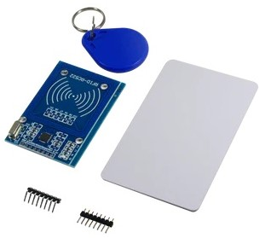**Features:**

* + It is very easy to use and assembling is also easy.
  + Onboard detection indication.
  + Effective distance range of 2cm.
  + The operating voltage generated is 5VDC.
  + The output voltage is 0 or 5VDC.

## Applications:

* + Augmentative communication devices
  + Car locking systems
  + Computers
  + Signage
  + Telephones

## 11.GSM MODULE

**Features:**

* The dual-Band 900/ 1800 MHz.
* Compliant to GSM phase 2/2+
* Dimensions: 24*24*3 mm.
* Controlling is done via AT commands
* The supply voltage range is 5V.
* It uses very low power of 1.5mA (sleep mode)

## Applications:

* + It can be connected to the internet globally.
  + It is used for sending and receiving messages
  + Uses the GSM library to make voice conversations.

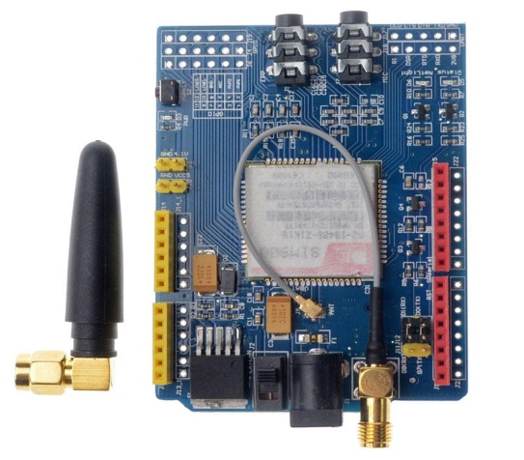

## 12.BUZZER :

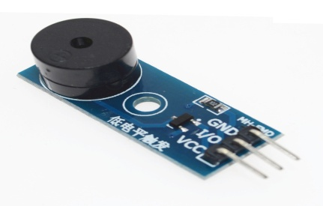

**Features:**

* + Operation Voltage: 5VDC
  + Frequency: 3,300Hz
  + Current: <15mA
  + SPL: 85dB/A10cm
  + Color: Black
  + Operating Temperature: -20c to +60c
  + Polarity: Position Pin marked on the surface
  + Number of pins: 2

## Applications:

* + Communication Devices
  + Electronics used in Automobiles
  + Alarm Circuits
  + Portable Devices

## RELAY:

## Features:

## Lighted Indicator Example: 480-6227-ND

## Mechanical indicator.

## It consists of a set of input terminals for a single or multiple control signals.

## A set of operating contact terminals.

## Test button.

## Resistor.

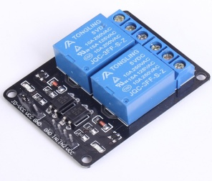

1. EM READER

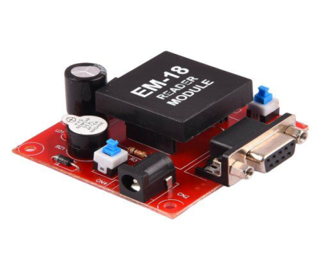

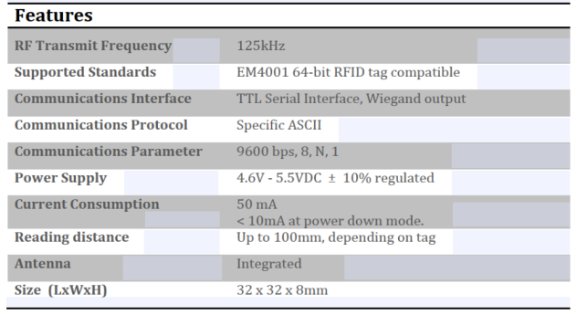

**IOT PLATFORM**

## ADAFRUIT.IO

## Adafruit.io is a cloud service, which means we operate it for you and you don't have to worry about it. You can access it via the Internet. Its primary purpose is to store and then retrieve info, but it is capable of much more!

**What can Adafruit IO help me with?**

• Online, real-time visualisation of your data

• Connect your idea to the internet: Motor control, sensing data reading, and more!

• Link projects to online services such as Twitter, RSS feeds, weather services, and so on. • Link your project to other internet-enabled devices.

• And the greatest part? You can do all of the above for free with Adafruit IO. The option is yours: no code or code.

Using our custom Whippersnapper firmware, you can now connect your devices with Adafruit.IO without writing a single word of code. Load the Whippersnapper firmware onto your board, enter your credentials, and connect it to electricity. Your board will immediately connect to your Adafruit.IO account.

You can then add buttons, switches, potentiometers, gauges, and other components to your board! Components are dynamically added to hardware, allowing you to interact, record, and stream data from your projects without writing code.

We have you covered if you prefer to dive in and code your own tasks. We have modules for Circuit Python, Arduino, Python, and other programming languages. For more sophisticated developers, check out our REST API and MQTT API.

## 

## Interact with your data.

## How to Set up Your Adafruit Dashboard

## 

**16 .LCD:**

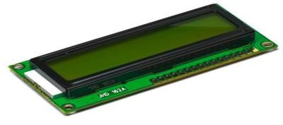

**Features:**

* 1. Input voltage:5v
  2. E-blocks compatible
  3. Low cost
  4. Ease to develop programming code using Flow code icons.

## Application:

1. Monitoring the recorded output.

## 17. SOFTWAREREQUIREMENT:

**a EMBEDDEDC**

## b ARDUINOSOFTWARE(IDE)

**c PYTHON**

## 18. EMBEDDEDC:

Embedded C is the most widely used computer language in the software industry for creating electronic devices. Every processor in an electronic device is linked to embedded software.

The programming of a part done particular processor functions. We use many electronic gadgets in our daily lives, such as phones, washing machines, digital cameras, and so on. The device operates on a microcontroller that is written by embedded.

The embedded C code shown in the block diagram above is used to blink the LED attached to port) of the microcontroller.

C code is favoured over other languages in embedded system programming. Because of the following factors.

• Simple to grasp

• Reliable

• Portability

• Scalability

We need a particular compiler to assist us here. producing microcontroller based results. Embedded C is commonly used to create microcontroller-based applications.

## ARDUINO SOFTWARE (IDE)

Download the most recent version from the download website. You have the option of using the Installer (.exe) or the Zip folders. We recommend using the first one, which loads everything you need to use the Arduino Software (IDE), including the drivers. The drivers must be directly installed with the Zip package. If you want to make a portable installation, the Zip file is also useful. When the download is complete, continue with the installation, and kindly allow the driver installation process when prompted by the operating system.

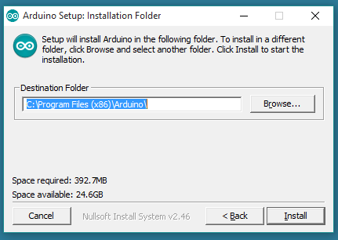

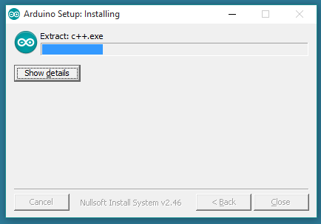

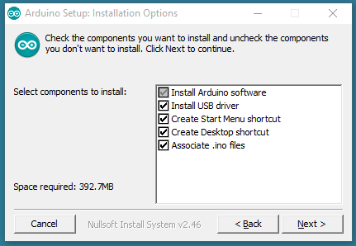An AVR ISP Compatible downloader is required to burn a fresh version of the Arduino boot loader to your UNO. Because ROBOTC cannot presently burn a boot loader onto an ArArduino board, you must obtain a copy of the most recent version of the Arduino open-source programming language.

## PYTHON

Python is a popular high-level programming language for general-purpose programming that was developed by Guido van Rossum and first published in 1991.Python is an interpreted language with a design philosophy. Python is a popular deep learning language because it has a large number of libraries and frameworks available for use. Here are some of the most important libraries and frameworks for deep learning in Python:

Num Py: A Python library for numerical computing that is used to perform mathematical operations on large data arrays and matrices.

Pandas: A Python data manipulation and analysis library for working with structured data.

Matplotlib: A Python visualisation library used to create plots, charts, and other visual representations of data.

Tensor Flow: Google's popular deep learning framework for building and training deep neural networks.

Keras is a high-level neural network API that runs on top of Tensor Flow (or other backend) and is used for building and training deep neural networks with a simpler, more user-friendly interface.

PyTorch is a deep learning framework created by Facebook that is used to build and train neural networks using a dynamic computational graph.

These libraries and frameworks offer a variety of tools for deep learning tasks like image and speech recognition, natural language processing, and others. Python allows researchers and developers to use these tools to create powerful and accurate deep learning models. to build neural networks. The language includes structures that allow for the creation of clear program’s on both a small and large scale. Python has a dynamic type system, automatic memory management, and supports a wide range of computing techniques, including object-oriented, functional programming, and procedural programming. Its standard collection is extensive and varied. Python code can operate on a variety of operating systems because there are Python interpreters for many of them.

METHODOLOGY/WORKING:

* In this project, we have used Arduino MEGA microcontroller which acts as brain of our system, hence the entire system program is stored in it.
* Here the use of the RFID and CURRENCY accepter module we can give the two options for the payment purpose. The RFID is used to make a payment using card and the CURRENCY accepter module is used to make a payment card less.
* The keypad is used to give access to the owner of the EV to enter the required details into the charging station.
* GSM module is used to update payment information for the user. Buzzer gives the alert for the start and end of the charging time.
* Whenever the person completed the payment relay will on and charging the vehicle will start. The LCD is used to provide the user with all the information of the device.

## Procedure:

* First the user decides to use whether the transaction is a card or card less.
* And if the chosen option is a card then the user uses the card to do the payment.
* If the transaction is card less then the transaction can be done using the real money which is through the image classification.
* Then after the transaction user can recharge their vehicle with their paid amount.
* If the user wants to drop the idea of charging the vehicle in middle then he can safely remove the charger from his vehicle.
* Because the details of his remaining charging is saved in our cloud.
* The user can access his amount of remaining charging
* By accessing the website we are providing
* The steps for checking the dashboard
* By clicking on the start button above as shown you can access the registration page after creating an account you can see the dashboard values.
* In first dashboard you can see that how much amount of charge has been used.
* In second Dashboard we can see that how much is there left for recharge when you visit the electric charge station.

.

## 21 USER INTRFACE

## Using this interface the user can access the dashboard

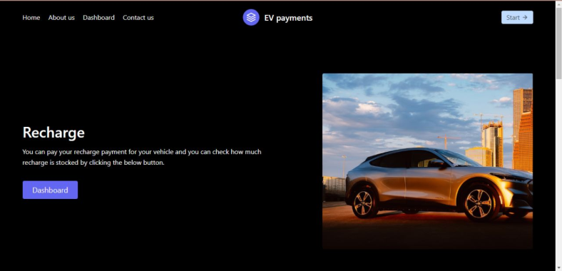

## DASHBOARD FOR DATA ANALYSIS:

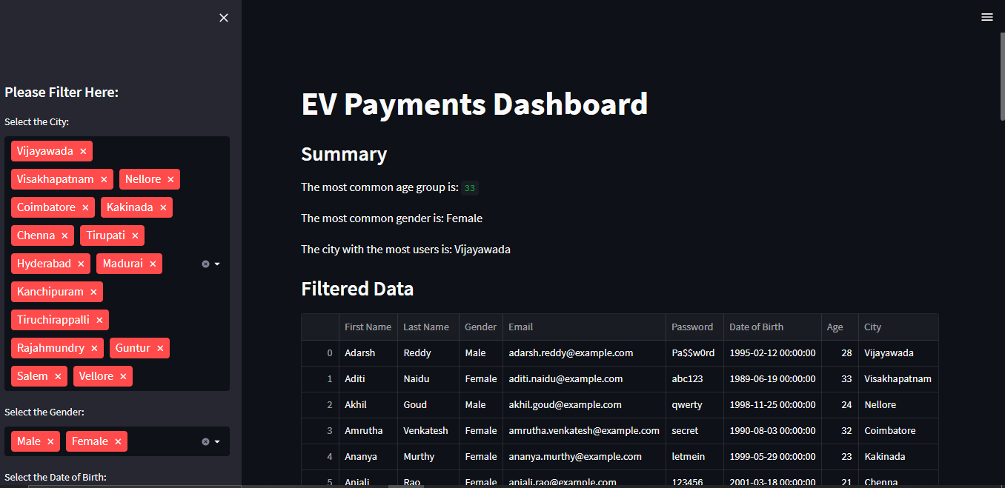

Age distribution pie chart generated using Stream lit

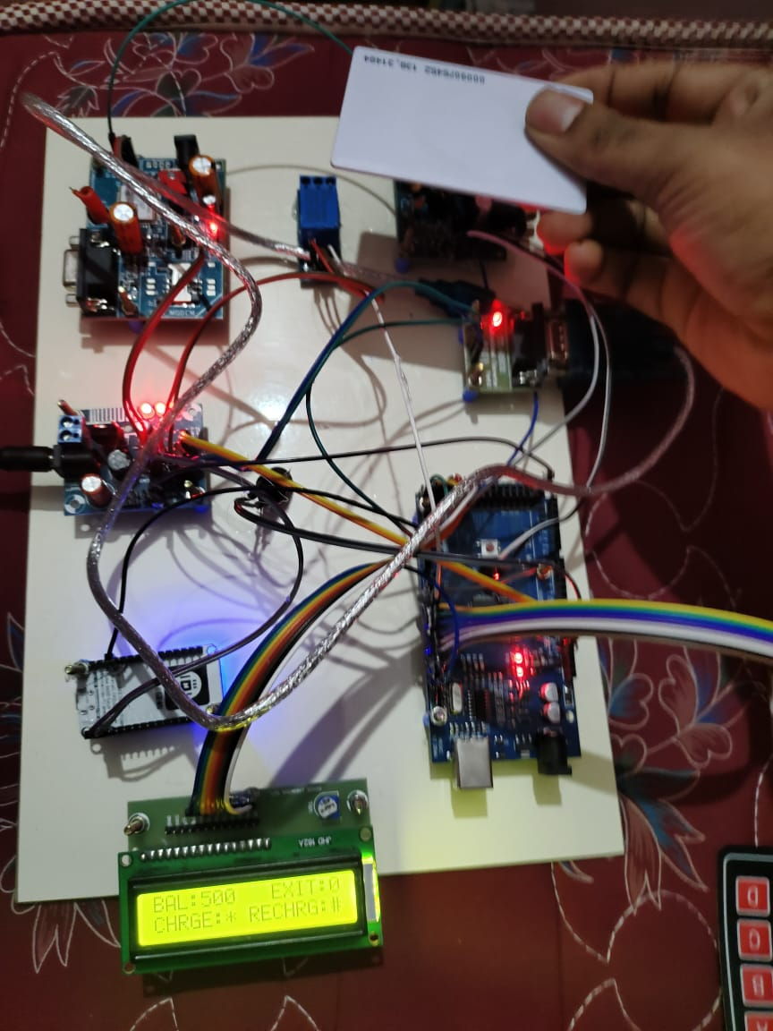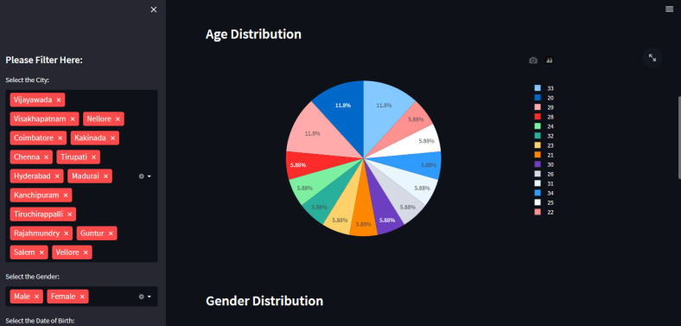

Gender distribution pie chart generated using streamlit

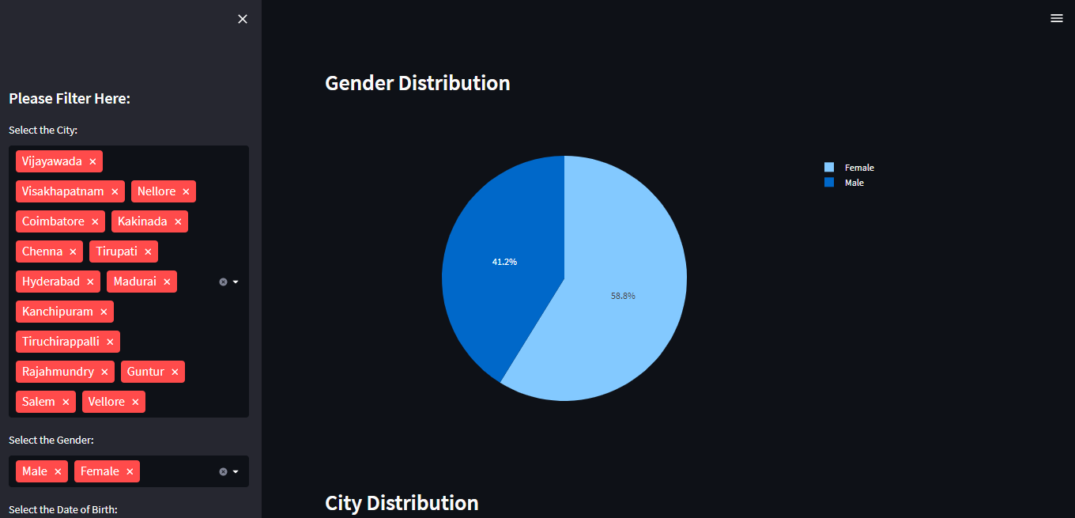

City distribution pie chart generated using streamlit

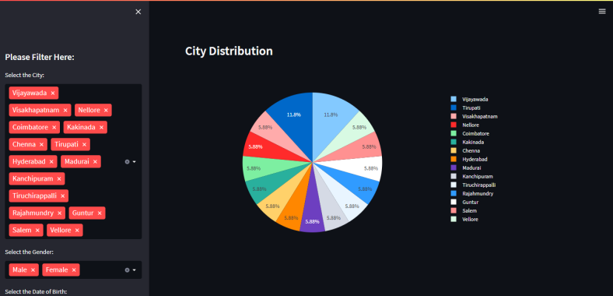

**OUTPUT:**

**WITHCARD TRANSACTION:**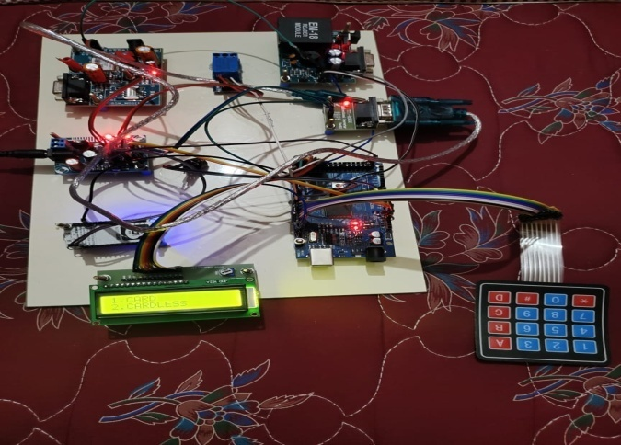

By selecting 1from keypad we can use card

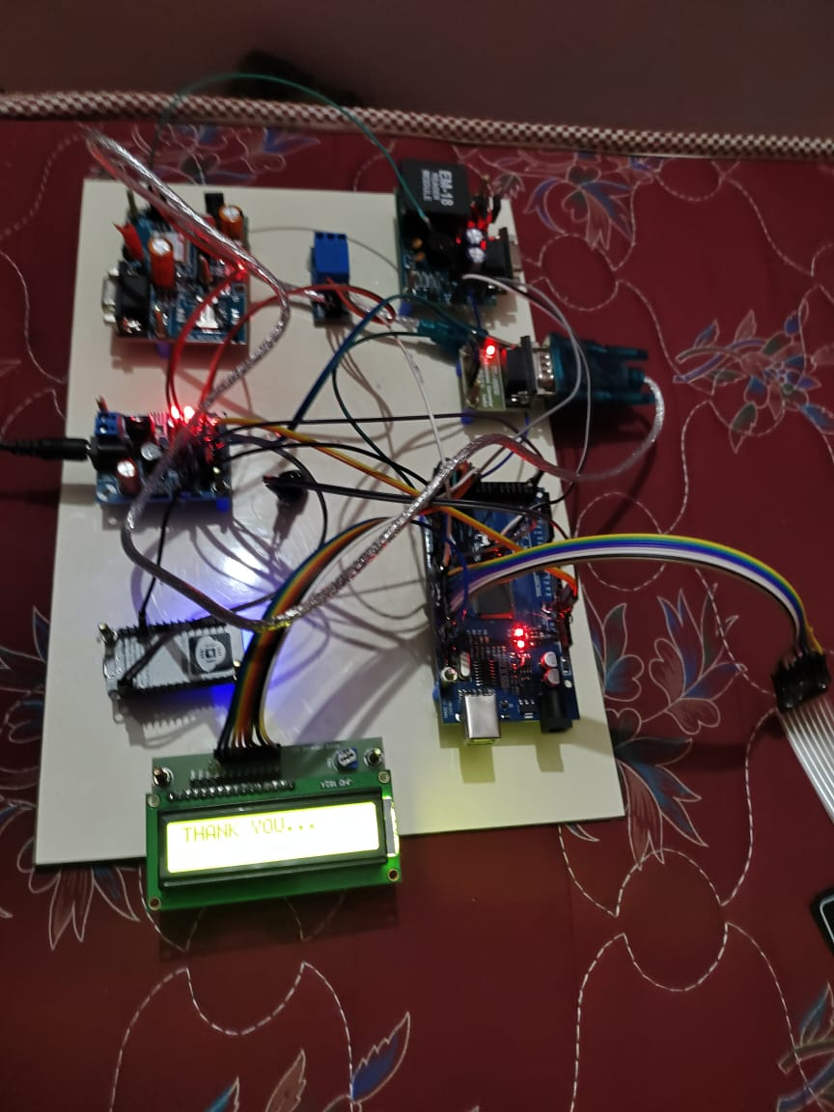

The card reader reads the card and shows the balance

.

Choose the amount

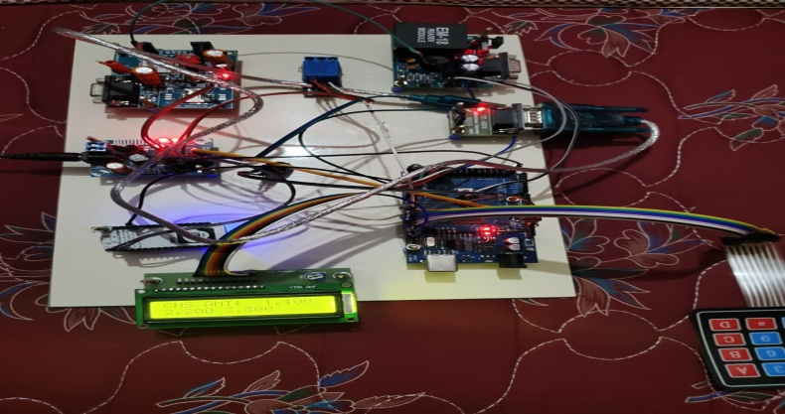

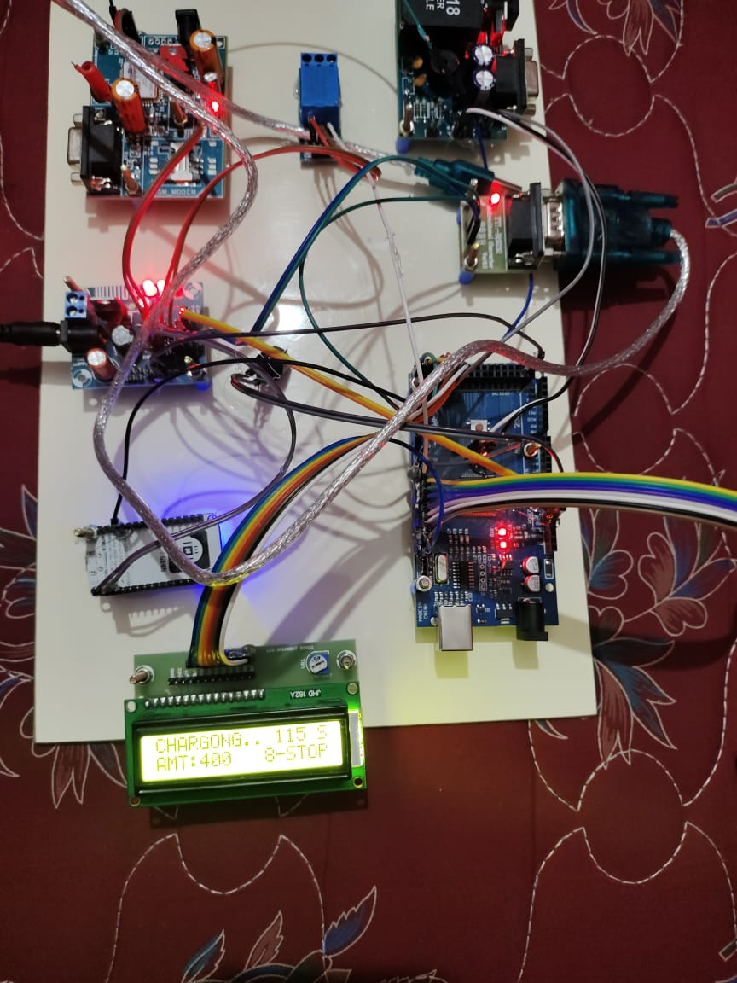 Charging has been started.

Thank you message showing on completion of charging

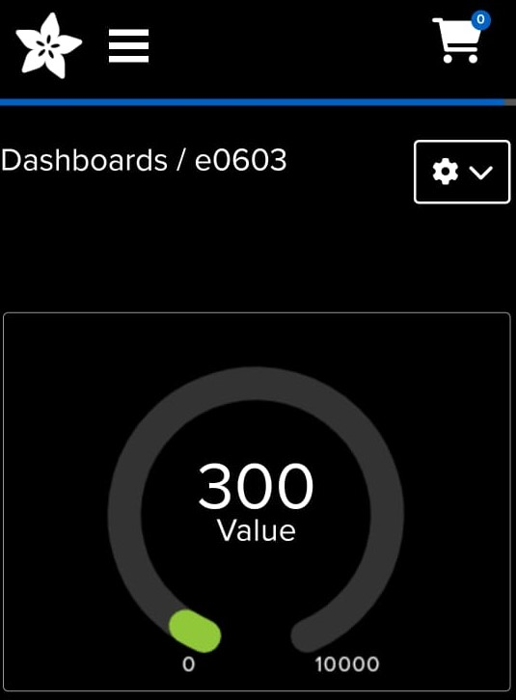 DASHBOARD : It is another platform where the user can access the below dashboard by entering the login credentials in our website.

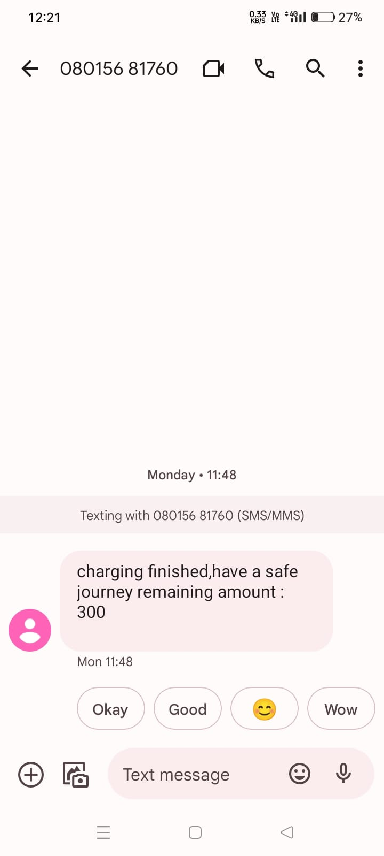 **SMS sent through GSM module**

## CONCLUSION:

## In conclusion, user-friendly AI hardware for EV charging using RFID is a promising solution for the challenges faced by electric vehicle owners. The implementation of RFID technology allows for easy and efficient charging processes by providing a convenient payment system and eliminating the need for physical cards.

## With the incorporation of AI technology, the charging process can be optimized to cater to the individual needs of the user, including energy-efficient charging and accurate billing. The use of user-friendly hardware and software improves the usability and accessibility of electric vehicle charging stations, ultimately contributing to the success and adoption of sustainable mobility solutions.

## Therefore, the integration of user-friendly AI hardware for EV charging using RFID technology should be prioritized in the development of EV charging infrastructure.

## 24.FUTURE ENHANCEMENT:

## • No fuel, less expensive to maintain.

## • Less harmful to the earth and lower in carbon•

## Reduced noise pollution and a smoother ride.

## • Concerns about range and we are going to provide

## multi user set up

## • Completely integrated into the AI system.

## 25. REFERENCES:

1. ChenW. R.,DaiC. H.,Liq.,MaL., WangT. H., and “power management strategy based on adaptive droop control for a fuel cell battery –super capacitor hybrid tramway,” IEEE transactions on vehicular technology, vol. 67, no. 7, pp. 5658–5670, jul. 2018.

2. ChenW. R.,HuangW. Q., J. W. Liu, LiQ.,Yany., and “hierarchical management control based on equivalent fitting circle and equivalent energy consumption method for multiple fuel cells hybrid power system,” IEEE transactions on industrial electronics, vol. 67, no. 4, pp. 2786–2797, apr. 2020.

3. ChenW. R., HanPu, Y., Li q., SuB., WangY. C. T. H., YinL. Z., and “A state machine control based on equivalent consumption minimization for fuel cell/supercapacitor hybrid tramway,” IEEE transactions on transportation electrification, vol. 5, no. 2, pp. 552–564, jun. 2019.

4. ChenW. R.,LiJ. C., LiQ., LiuM., MengX., QiuY. B., Wangt. H., WangX. T., and “an optimized energy management strategy for fuel cell hybrid power system based on maximum efficiency range identification,” journal of power sources, vol. 445, pp. 227333, jan. 2020.

5. ChenS., ChenL., and MaD. Z., Sunq. Y., “quasi-z-source network based hybrid power supply system for aluminum electrolysis industry,” IEEE transactions on industrial informatics, vol. 13, no. 3, pp. 1141– 1151, jun. 2017.

6. Deng, DorrellG D., HuS.,SunF. C.,WangZ. P., ZhangX. and “multi objective optimal sizing of hybrid energy storage system for electric vehicles,” IEEE transactions on vehicular technology, vol. 67, no. 2, pp. 1027–1035, feb. 2018.

7. Feng.H, Lukic.S, Srdic .S,Tu .H, and “Extreme fast charging of electric vehicles: a technology overview,” IEEE Transactions on Transportation Electrification, vol. 5, no. 4, pp. 861–878, Dec. 2019.

8. Iravani M. R. and Mahfouz M. M , “Grid-integration of battery-enabled dc fast charging station for electric vehicles,” IEEE Transactions on Energy Conversion, vol. 35, no. 1, pp. 375–385, Mar. 2020.

9. Kezunovic .M, Yan.Q ,Zhang B., and “Optimized operational cost reduction for an EV charging station integrated with battery energy storage and PV generation,” IEEE Transactions on Smart Grid, vol. 10, no. 2, pp. 2096–2106, Mar. 2019.

10. Li Y. W and Nejabatkhah.F, “Overview of power management strategies of hybrid AC/DC microgrid,” IEEE Transactions on Power Electronics, vol. 30, no. 12, pp. 7072–7089, Dec. 2015